

**American International University- Bangladesh**

**CSC 3215: Web Technologies**

**CO2 and CO4 Evaluation**

**Finished Project Report**

**Summer 2020-2021**

**Project Title: Student- Alumni Hub**

**Section: F**

|  |  |
| --- | --- |
| Student Name | Student Id |
| Md. Al Mamun Emon | **18-37860-2** |
| Faisal Ahmed Shuvo | **17-35643-3** |
| Sumaiya Ashreen | **18-36658-1** |

**Project Description:**

The purpose of the project entitled as “Student Alumni Hub” is to computerize the communication system of student and alumni to develop web application which is user friendly, simple, fast and cost-effective. It deals with the admin, student and alumni information and also to contact with different user through their information and much more features. The main function of the system is to log in and register user and user information, to check user information through this website. Traditionally, it was done manually. Our main focus is to design a unique and interactive portal that will improve experience for students and alumni of any educational institution. The whole system will through the help of internet. When a user tries to login, it will validate if he is registered or not. There are php and js validation for server end and client end. For registration process, it is all the same validation. In the website there are different sections for admin and other users. Admin can manipulate or edit or delete other users.

**Project Folder Structure:**

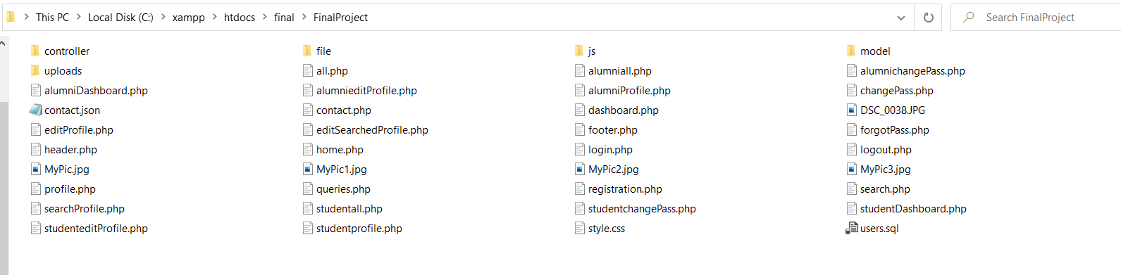

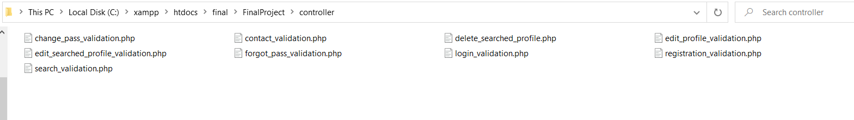





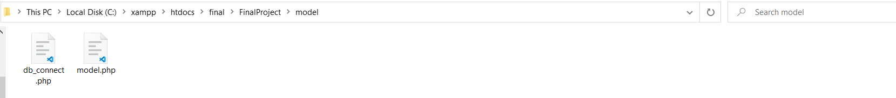

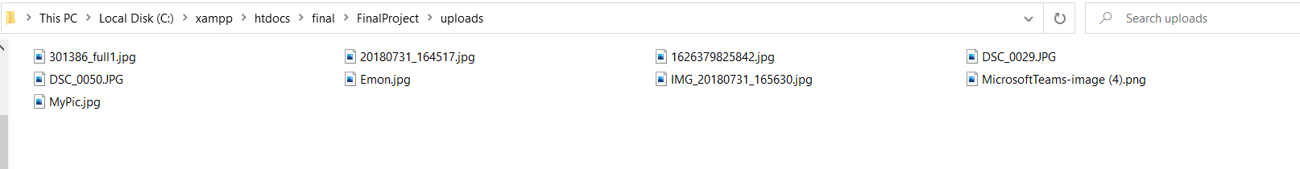

**Core Modules of the Project:**

**registration.php**

<?php

include('header.php');

require_once('controller/registration_validation.php');

?>

<form method="post" action="" enctype="multipart/form-data" onsubmit="validate()">

<fieldset style="width:500px">

<legend><b>REGISTRATION</b></legend>

<table border="0">

<tr>

<td>Name</td>

<td>:

<input type="text" name="name" id="name" onkeyup="nameCheck()" onblur="nameCheck()">

<span id="msg1"> </span>

<span class="error">* <?php echo $nameErr; ?></span>

</td>

</tr>

<tr>

<td colspan="2">

<hr>

</td>

</tr>

<tr>

<td>Email</td>

<td>:

<input type="text" name="email" id="email" onkeyup="emailCheck()" onblur="emailCheck()">

<span id="msg2"> </span>

<span class="error">* <?php echo $emailErr; ?></span>

</td>

</tr>

<tr>

<td colspan="2">

<hr>

</td>

</tr>

<tr>

<td>User Name</td>

<td>:

<input type="text" name="uname" id="uname" onkeyup="unameCheck()" onblur="unameCheck()">

<span id="msg3"> </span>

<span class="error">* <?php echo $unameErr; ?></span>

</td>

</tr>

<tr>

<td colspan="2">

<hr>

</td>

</tr>

<tr>

<td>Password</td>

<td>:

<input type="password" name="pass" id="pass" onkeyup="passCheck()" onblur="passCheck()">

<span id="msg4"> </span>

<span class="error">* <?php echo $passErr; ?></span>

</td>

</tr>

<tr>

<td colspan="2">

<hr>

</td>

</tr>

<tr>

<td>Confirm Password</td>

<td>:

<input type="password" name="cPass" id="cPass" onkeyup="cPassCheck()" onblur="cPassCheck()">

<span id="msg5"> </span>

<span class="error">* <?php echo $cpassErr; ?></span>

</td>

</tr>

<tr>

<td colspan="2">

<hr>

</td>

</tr>

<tr>

<td colspan="2">

<fieldset>

<legend>Gender</legend>

<input type="radio" name="gender" value="Male" id="gender">Male

<input type="radio" name="gender" value="Female" id="gender">Female

<input type="radio" name="gender" value="Other" id="gender">Other

</fieldset>

<span id="msg6"> </span>

<span class="error">* <?php echo $genderErr; ?></span>

</td>

</tr>

<tr>

<td colspan="2">

<hr>

</td>

</tr>

<tr>

<td colspan="2">

<fieldset>

<legend>Date Of Birth</legend>

<input type="tel" name="date" id="date" size="1" onkeyup="dateCheck()" onblur="dateCheck()"> /

<input type="tel" name="month" id="month" size="1" onkeyup="monthCheck()" onblur="monthCheck()"> /

<input type="tel" name="year" id="year" size="1" onkeyup="yearCheck()" onblur="yearCheck()"> <i>(dd/mm/yy)</i>

</fieldset>

<span id="msg7"> </span>

<span id="msg8"> </span>

<span id="msg9"> </span>

<span class="error">* <?php echo $ddErr; ?></span>

<span class="error">* <?php echo $mmErr; ?></span>

<span class="error">* <?php echo $yyyyErr; ?></span>

</td>

</tr>

<tr>

<td colspan="2">

<hr>

</td>

</tr>

<tr>

<td colspan="2">

<fieldset>

<legend>Department</legend>

<input type="radio" name="dept" value="CSE" id="dept">CSE

<input type="radio" name="dept" value="EEE" id="dept">EEE

<input type="radio" name="dept" value="BBA" id="dept">BBA

</fieldset>

<span id="msg10"> </span>

<span class="error">* <?php echo $deptErr; ?></span>

</td>

</tr>

<tr>

<td colspan="2">

<hr>

</td>

</tr>

<tr>

<td colspan="2">

<fieldset>

<legend>Position</legend>

<input type="radio" name="position" value="Student" id="position">Student

<input type="radio" name="position" value="Alumni" id="position">Alumni

</fieldset>

<span id="msg11"> </span>

<span class="error">* <?php echo $positionErr; ?></span>

</td>

</tr>

<tr>

<td colspan="2">

<hr>

</td>

</tr>

<tr>

<td>ID</td>

<td>:

<input type="text" name="id" id="id" onkeyup="idCheck()" onblur="idCheck()">

<span id="msg12"> </span>

<span class="error">* <?php echo $idErr; ?></span>

</td>

</tr>

<tr>

<td colspan="2">

<hr>

</td>

</tr>

<tr>

<td>Profile Picture</td>

<td>:

<input type="file" name="photo" id="photo"><br>

<span id="msg13"> </span>

<span class="error">* <?php echo $photoErr; ?></span>

</td>

</tr>

<tr>

<td><br></td>

</tr>

<tr>

<td colspan="2">

<input type="submit" name="submit" value="Submit">

<input type="reset" value="reset">

</td>

</tr>

</table>

</fieldset>

</form>

<?php

include('footer.php');

?>

**Login.php**

<?php

include('header.php');

require_once('controller/login_validation.php');

?>

<form method="post" action="">

<fieldset style="width:400px">

<legend><b>LOG IN</b></legend>

<table>

<tr>

<td>User Name:</td>

<td><input type="text" name="uname" id="luname" value="<?php if (isset($_COOKIE["user"])) {

echo $_COOKIE["user"];

} ?>" onkeyup="logUnameCheck()" onblur="logUnameCheck()">

</td>

</tr>

<tr>

<td>Password:</td>

<td><input type="password" name="pass" id="lpass" value="<?php if (isset($_COOKIE["pass"])) {

echo $_COOKIE["pass"];

} ?>"onkeyup="logPassCheck()" onblur="logPassCheck()">

</td>

</tr>

<tr>

<td>

<span id="msg13"> </span>

</td>

</tr>

<tr>

<td colspan="2">

<hr>

</td>

</tr>

<tr>

<td colspan="2">

<input type="checkbox" name="remember" id="">Remember me

</td>

</tr>

<tr>

<td colspan="2">

</td>

</tr>

<tr>

<td>

<br>

<input type="submit" name="submit" value="Log In">

<!-- <button>Login</button> -->

<a href="forgotpass.php"> Forgot Password?</a>

</td>

</tr>

</table>

</fieldset>

</form>

<?php

include('footer.php');

?>

**Studenteditprofile.php**

<?php

session_start();

include('header.php');

require_once('controller/edit_profile_validation.php');

if (isset($_SESSION['flag'])) {

?>

<tr>

<td>

<b>

<h2>&nbsp;&nbsp;Account</h2>

</b>

<hr>

<ul>

<li><a href="studentDashboard.php">Dashboard</a></li>

<li><a href="studentprofile.php">View Profile</a></li>

<li><a href="studenteditProfile.php">Edit Profile</a></li>

<li><a href="studentchangePass.php">Change Password</a></li>

<li><a href="studentall.php">View All Profiles</a></li>

<!-- <li><a href="search.php">Search an User</a></li> -->

<li><a href="studentlogout.php">Logout</a></li>

</ul>

</td>

<td colspan="2" rowspan="2">

<fieldset>

<legend><b>

<h2>EDIT PROFILE</h2>

</b></legend>

<form method="post" action="" enctype="multipart/form-data" onsubmit="validate()">

<table border="0" width="100%">

<tr>

<td>Name</td>

<td>:

<input value="<?php echo $_SESSION['name']; ?>" type="text" id="name" name="ename" onkeyup="nameCheck()" onblur="nameCheck()">

<span id="msg1"> </span>

<span class="error">* <?php echo $nameErr; ?></span>

</td>

</tr>

<tr>

<td colspan="2">

<hr>

</td>

</tr>

<tr>

<td>Email</td>

<td>: <input type="email" name="eemail" id="email" value="<?php echo $_SESSION['email']; ?>" onkeyup="emailCheck()" onblur="emailCheck()">

<span id="msg2"> </span>

<span class="error">* <?php echo $emailErr; ?></span>

</td>

</tr>

<tr>

<td colspan="2">

<hr>

</td>

</tr>

<tr>

<td>Gender:</td>

<td>:

<?php

if (!empty($_SESSION['gender'])) {

if ($_SESSION['gender'] == "Male") { ?>

<input type="radio" name="egender" value="Male" id="" checked>Male

<input type="radio" name="egender" value="Female" id="">Female

<input type="radio" name="egender" value="Other" id="">Other

<?php

} else if ($_SESSION['gender'] == "Female") { ?>

<input type="radio" name="egender" value="Male" id="">Male

<input type="radio" name="egender" value="Female" id="" checked>Female

<input type="radio" name="egender" value="Other" id="">Other

<?php

} else { ?>

<input type="radio" name="egender" value="Male" id="">Male

<input type="radio" name="egender" value="Female" id="">Female

<input type="radio" name="egender" value="Other" id="" checked>Other

<?php }

} ?>

</td>

</tr>

<tr>

<td colspan="2">

<hr>

</td>

</tr>

<tr>

<td>

Date of Birth

</td>

<td>

<input type="tel" name="edate" id="date" value="<?php echo $_SESSION['date']; ?>" size="1" onkeyup="dateCheck()" onblur="dateCheck()"> /

<input type="tel" name="emonth" id="month" value="<?php echo $_SESSION['month']; ?>" size="1" onkeyup="monthCheck()" onblur="monthCheck()"> /

<input type="tel" name="eyear" id="year" value="<?php echo $_SESSION['year']; ?>" size="1" onkeyup="yearCheck()" onblur="yearCheck()"><i> (dd/mm/yy)</i>

<span class="error">* <?php echo $ddErr; ?></span>

<span class="error">* <?php echo $mmErr; ?></span>

<span class="error">* <?php echo $yyyyErr; ?></span>

<br><span id="msg7"> </span>

<br><span id="msg8"> </span>

<br><span id="msg9"> </span>

</td>

</tr>

<tr>

<td colspan="2">

<hr>

</td>

</tr>

<tr>

<td>Department:</td>

<td>:

<?php

if (!empty($_SESSION['dept'])) {

if ($_SESSION['dept'] == "CSE") { ?>

<input type="radio" name="edept" value="CSE" id="" checked>CSE

<input type="radio" name="edept" value="EEE" id="">EEE

<input type="radio" name="edept" value="BBA" id="">BBA

<?php

} else if ($_SESSION['dept'] == "EEE") { ?>

<input type="radio" name="edept" value="CSE" id="">CSE

<input type="radio" name="edept" value="EEE" id="" checked>EEE

<input type="radio" name="edept" value="BBA" id="">BBA

<?php

} else { ?>

<input type="radio" name="edept" value="CSE" id="">CSE

<input type="radio" name="edept" value="EEE" id="">EEE

<input type="radio" name="edept" value="BBA" id="" checked>BBA

<?php }

} ?>

</td>

</tr>

<tr>

<td colspan="2">

<hr>

</td>

</tr>

<tr>

<td>Profile Picture</td>

<td> <img src="uploads/<?php echo $_SESSION['photo'] ?>" height="200px" weidth="200px" alt=""></td>

</td>

</tr>

<tr>

<td colspan="2">

<hr>

</td>

</tr>

<tr>

<td>Upload new picture</td>

<td><input type="file" name="photo"></td>

</td>

</tr>

<tr>

<Td><br></Td>

</tr>

<tr>

<td><input type="submit" name="change" value="Submit"></td>

</tr>

</table>

</form>

</fieldset>

</td>

</tr>

<tr>

<td height="390px">

<?php

include('footer.php');

?>

<?php

} else {

header('location: login.php');

}

?>